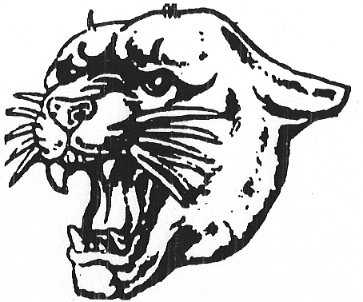
MONTGOMERY
HIGH SCHOOL

BOYS SWIM RECORDS

SCHOOL RECORDS |  |  |  | POOL RECORDS
NAME | TIME | YEAR |  | NAME | TIME |  | SCHOOL
Justin Tong  James Yan  Ethan Feng  Matthew Chen | 1:35.44 | 2020 | 200 MEDLEY  RELAY | Jaden Lee  Gregory Yukhvid  Aaron Roy  Christopher Wasko |  | 1:32.27 | BR  2025
Scott Heil | 1:41.85 | 2010 | 200 FREESTYLE | Brad Zdroik | 1:40.89 |  | HILLS  2014
Ethan Feng | 1:54.15 | 2020 | 200 I.M. | Matt Fallon | 1:48.53 |  | PING  2020
Zaccharie Ouzilou | 21.08 | 2022 | 50 FREESTYLE | Roman Jones | 20.37 |  | PING  2023
Collin McManus | 238.25 | 2015 | 1 Meter Diving  6 Dives | Seamus Harding | 342.15 |  | ND  2019
Collin McManus | 468.25 | 2015 | 1 Meter Diving  11 Dives | Seamus Harding | 635.90 |  | ND  2019
Zaccharie Ouzilou | 50.67 | 2022 | 100 BUTTERFLY | Roman Jones | 48.32 |  | PING  2023
Matthew Chen | 46.57 | 2020 | 100 FREESTYLE | Roman Jones | 43.90 |  | PING  2022
Scott Heil | 4:39.93 | 2010 | 500 FREESTYLE | Bradley Wachenfeld | 4:32.13 |  | RIDGE  2012
Zaccharie Ouzilou  Colin Liu  Ethan Feng  Matthew Chen | 1:28.25 | 2020 | 200 FREESTYLE RELAY | Jaden Lee  Gregory Yukhvid  Aaron Roy  Christopher Wasko | 1:24.42 |  | BR  2025
Zaccharie Ouzilou | 50.19 | 2022 | 100 BACKSTROKE | Roman Jones | 48.46 |  | PING  2022
Zack Warner | 54.89 | 2014 | 100 BREASTSTROKE | Matt Fallon | 54.66 |  | PING  2019
Colin Liu  Ethan Feng  Edwin Liang-Gilman  Matthew Chen | 3:10.99 | 2020 | 400 FREESTYLE RELAY | Sebastian Lutz  Matt Zeikel  William Zhang  Jamie Finnegan | 3:10.52 |  | PING  2015

