# Micro III-IV Review Questions

**Multiple Choice**

*Identify the choice that best completes the statement or answers the question.*

____ 1. Factor demand is said to be derived demand because it:

1. requires the use of other factors.
2. depends on product demand.
3. has a downward-sloping demand curve.
4. has a constant marginal factor cost.
5. depends on the cost of hiring the factor.

**Figure 69-1: The Value of the Marginal Product Curve**

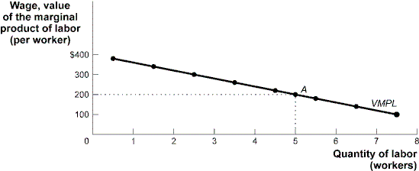

____ 2. (Figure 69-1: The Value of the Marginal Product Curve) In the figure, the *VMPL* curve will shift to the right if: *(Note: VMPL is sometimes used in place of MRP of Labor under perfectly competitive conditions.)*

1. the wage rate increases.
2. a technological advance makes labor more productive.
3. the price of the good decreases.
4. the wage rate decreases.
5. the price of a complementary input increases.

____ 3. A decrease in the demand for pastry chefs may come about because of an:

1. increased concern for fitness.
2. increase in the market wage rate for pastry chefs.
3. increase in the productivity of pastry chefs.
4. increase in the supply of other factors that pastry chefs use.
5. decrease in the price of other factors that are employed with pastry chefs.

| **Number**  **of Workers** | **Output**  **of Corn**  **(units of corn)** |
| --- | --- |
| 0 | 0 |
| 1 | 30 |
| 2 | 58 |
| 3 | 79 |
| 4 | 94 |
| 5 | 104 |
| 6 | 108 |
| 7 | 110 |
| **Table 69-2: Workers and Corn Output** | |

____ 4. (Table 69-2: Workers and Corn Output) Laura is a price-taking farmer who produces corn. Assume the wage rate for workers is $125 and the price per unit of corn is $10. The table shows Laura's production function. To maximize profits Laura should employ ________ workers.

1. two
2. three
3. four
4. six
5. five

____ 5. Max employs both labor and capital to produce his trinkets. Currently the last unit of labor employed has a marginal product of 15 units. The last unit of capital employed has a marginal product of 40 units. The price of labor is $3 per unit and the price of capital is $10 per unit. If Max is going to find the least-cost combination of labor and capital, he needs to ____ his employment of labor and ____ his employment of capital.

a. maintain; maintain

b. decrease; increase

c. decrease; decrease

d. increase; increase

e. increase; decrease

____ 6. If a union is able to bargain for a wage that is higher than the equilibrium, this means that:

1. all workers will earn a wage equal to their value of marginal product.
2. some excess supply of labor or unemployment will result at this wage rate.
3. compensating differentials will be erased in this market.
4. diminishing returns will not exist in this market.
5. the demand for nonunion labor will decrease.

____ 7. A market economy, without any government regulation, will produce:

1. too little pollution.
2. too much pollution.
3. the socially optimal quantity of pollution.
4. the amount of pollution that maximizes total surplus.
5. zero pollution.

____ 8. An externality is said to exist when:

1. individuals impose costs or benefits on others but have no incentive to take these costs and benefits into account.
2. individuals impose costs or benefits on others, and the market provides incentives to take these costs and benefits into account.
3. individual actions are affected by external forces; for example, the loss of U.S. jobs due to competition from abroad is an externality.
4. individual actions are affected by government policies (such as taxes) that are externally imposed on the market.
5. the quantity of a good produced in the market is the socially optimal quantity.

____ 9. Well-functioning markets allow:

1. mutually beneficial trades to take place.
2. consumers to gain at the expense of producers.
3. producers to reap greater benefits since they have greater power in the market.
4. property rights to be unnecessary components of effective distribution.
5. producers to gain at the expense of consumers.

____ 10. Suppose the production of DVDs generates sulfur dioxide, an air pollutant. Then the equilibrium market quantity of DVDs produced and consumed:

1. is less than the socially optimal quantity, due to the negative externality.
2. is less than the socially optimal quantity, due to the positive externality.
3. equals the socially optimal quantity and there is no externality.
4. is more than the socially optimal quantity, due to the positive externality.
5. is more than the socially optimal quantity, due to the negative externality.

____ 11. Automobile emissions generate pollution and cause higher costs and discomfort to residents of a city. In this case:

1. too few of society's resources are being used to operate automobiles.
2. the externality can be internalized into the market by imposing a specific tax on drivers.
3. there is an external benefit to society from operating automobiles.
4. the externality can be internalized into the market by granting a specific subsidy to drivers.
5. the market price of automobiles is too high.

____ 12. When an activity like education generates a positive externality, the:

a. market demand curve is below the marginal social benefit curve.

b. market demand curve is above the marginal social benefit curve.

c. marginal cost of production is below the market demand curve.

d. market will produce more than the efficient level of output.

e. market will produce the efficient level of output.

**Figure 75-5: Model of a Competitive Market**

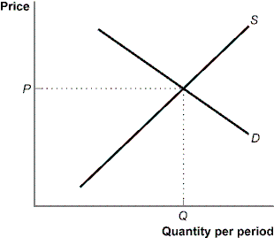

____ 13. (Figure 75-5: Model of a Competitive Market) If there are no external benefits or costs, the output at *Q* will be:

1. larger than is socially desirable.
2. smaller than is socially desirable.
3. efficient.
4. inefficient.
5. generating deadweight loss in this market.

____ 14. Oscar owns a meat processing plant that emits unpleasant odors that waft across the city. Because his production of processed meat provides a negative externality to the community, it must be the case that at the market equilibrium quantity, the marginal social:

1. cost of processed meat exceeds the market price.
2. benefit of processed meat exceeds the market price.
3. cost of processed meat is lower than the market price.
4. benefit of processed meat is lower than the market price.
5. cost of processed meat equals the market price.

**Figure 75-8: Marginal Private Benefits and Marginal Social Benefits**

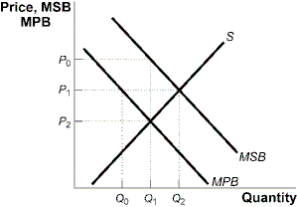

____ 15. (Figure 75-8: Marginal Private Benefits and Marginal Social Benefits) Without government intervention, this market will produce ________ units at a price of ________. *(Note: S = MSC, assuming no negative externalities, and MPB = D)*

1. *Q0; P0*
2. *Q1; P0*
3. *Q1; P2*
4. *Q2; P1*
5. *Q1; P1*

____ 16. (Figure 75-8: Marginal Private Benefits and Marginal Social Benefits) If government achieves this socially optimal level, it does so by:

1. imposing a per-unit tax equal to P1 – P2.
2. providing a per-unit subsidy of P0 – P2.
3. mandating consumption at output level Q1.
4. leaving the quantity at the initial private market-clearing quantity and price.
5. providing a per-unit subsidy of P1 – P2.

**Scenario 50-1: Market for Taxi Rides**

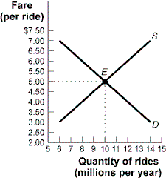

| **Fare**  **(per ride)** | **Quantity Demanded**  **(millions of**  **rides per year)** | **Quantity Supplied**  **(millions of**  **rides per year)** |
| --- | --- | --- |
| $7.00 | 6 | 14 |
| 6.50 | 7 | 13 |
| 6.00 | 8 | 12 |
| 5.50 | 9 | 11 |
| 5.00 | 10 | 10 |
| 4.50 | 11 | 9 |
| 4.00 | 12 | 8 |
| 3.50 | 13 | 7 |
| 3.00 | 14 | 6 |

____ 17. (Scenario 50-1: Market for Taxi Rides) The figure represents a competitive market for taxi rides. If the government now imposes an excise tax of $1 per ride (causing the supply curve to shift upward by that amount), then the government will collect tax revenues of ________, which might be used for worthwhile purposes, *but* there will be a deadweight loss to society of ________ caused by this tax.

1. $9 million; $0.5 million
2. $16 million; $2 million
3. $21 million; $3 million
4. $24 million; $4 million
5. $12 million; $4 million

____ 18. Suppose the government imposes a $4 excise tax on Good Y. If the demand for Good Y is perfectly inelastic and the supply curve is elastic, then the price of Good Y will:

1. increase by more than $4.
2. increase by exactly $4.
3. increase, but by less than $4.
4. remain constant.
5. decrease, but by less than $4.

____ 19. Suppose the price elasticity of demand for yachts equals 4.04, while the price elasticity of supply for yachts equals 0.22. If Congress reinstates a luxury tax on yachts, how will the burden of the tax be divided?

1. Yacht buyers will pay the entire tax while yacht builders will pay no tax at all.
2. Yacht buyers will pay a larger share than yacht builders.
3. Yacht builders and buyers will pay an equal share.
4. Yacht builders will pay the entire tax while yacht buyers will pay no tax at all.
5. Yacht builders will pay a larger share than yacht buyers.

**Figure 50-9: Market for Blue Jeans**

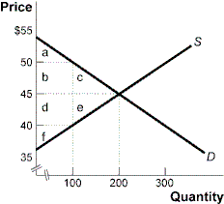

____ 20. (Figure 50-9: Market for Blue Jeans) The government recently levied a $10 tax on the producers of blue jeans. Using the graph, identify the area(s) that represent tax revenue.

1. a + b + c
2. b + d
3. c + e
4. d + e + f
5. a + b + d + f

____ 21. (Figure 50-9: Market for Blue Jeans) The government recently levied a $10 tax on the producers of blue jeans. Using the graph, identify the area(s) that represent the sum of consumer and producer surplus after the tax was levied.

1. a + b + c
2. a + b + c + d + e + f
3. d + e + f
4. a + f
5. a + b + d + f

____ 22. (Figure 50-9: Market for Blue Jeans) The government recently levied a $10 tax on the producers of blue jeans. Using the graph, identify the area(s) that represent deadweight loss.

1. a + b + c
2. b + d
3. c + e
4. d + e + f
5. a + b + d + f

____ 23. Paying a tax of $10 on an income of $100, a tax of $25 on an income of $200, and a tax of $60 on an income of $300 is an example of a:

1. progressive tax.
2. proportional tax.
3. regressive tax.
4. flat tax.
5. sales tax.

____ 24. Suppose the small town of Falls Valley estimates the marginal cost of providing one more treatment for mosquito control at $100,000. The town should provide the additional mosquito control only if the marginal:

1. benefit for any individual citizen is at least $100,000.
2. benefit of the last individual citizen is zero.
3. social cost of mosquito control is more than $100,000.
4. social cost of mosquito control is less than $100,000.
5. benefit for all individual citizens adds up to at least $100,000.

**Figure 77-1: Natural Monopoly**

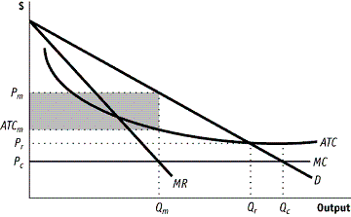

____ 25. (Figure 77-1: Natural Monopoly) The figure above shows a natural monopoly. If the firm is regulated so that the outcome is socially efficient, what will be the corresponding price and quantity?

|  | **Price** | **Quantity** |
| --- | --- | --- |
| (A) | ATCm | Qm |
| (B) | Pr | Qr |
| (C) | Pm | Qm |
| (D) | Pc | Qc |
| (E) | MC | Qc |

a. A

b. B

c. C

d. D

e. E

____ 26. The government has decided to regulate a natural monopoly so that the firm produces the break-even level of output. Compared to the unregulated outcome, one positive consequence of this decision is that:

1. the firm will earn very high and “unfair” economic profits.
2. the firm will be encouraged to reduce output and increase the price.
3. the government may need to subsidize the firm’s economic losses.
4. deadweight loss will decrease.
5. consumer surplus will fall.

____ 27. If a nation's Gini coefficient is rising over time, it is an indicator of:

1. an increase in the poverty rate.
2. a decrease in the poverty rate.
3. an increase in income inequality.
4. a decrease in income inequality.
5. a decrease in a nation’s overall wealth.

S

D = MRP

wage

Quantity of labor

W*

L*

____ 28. In the labor market above, an increase in the productivity of labor, when everything else stays the same, will lead to _______________ in the equilibrium quantity of labor and _____________ in the equilibrium price of labor.

1. a decrease; an increase
2. an increase; a decrease
3. a decrease; a decrease
4. an increase; an increase
5. an increase; no change

____ 29. In the labor market above, a decrease in the price of the good produced, when everything else stays the same, will lead to _______________ in the equilibrium quantity of labor and _____________ in the equilibrium price of labor.

1. a decrease; an increase
2. an increase; a decrease
3. a decrease; a decrease
4. an increase; an increase
5. an increase; no change

____ 30. Assume a monopsonistic firm takes control of all hiring in the above labor market. How will the quantity of labor hired and the equilibrium wage change?

1. employment increases; wage decreases
2. employment increases; wage increases
3. employment decreases; wage decreases
4. employment decreases; wage increases
5. employment does not change; wage decreases

____ 31. Assume an exclusive union gains control of the supply of labor in the competitive market above. Which of the following is not a strategy the union could use to increase wages?

1. Restricting union membership through aptitude testing
2. Reducing the apprenticeship period needed to become a certified union member
3. Charging higher union membership fees
4. Advertising for the products union workers produce
5. Training union workers in the latest production techniques

**Micro III-IV Review Questions**

**Answer Section**

**MULTIPLE CHOICE**

1. ANS: B

2. ANS: B

3. ANS: A

4. ANS: C

5. ANS: E

6. ANS: B

7. ANS: B

8. ANS: A

9. ANS: A

10. ANS: E

11. ANS: B

12. ANS: A

13. ANS: C

14. ANS: A

15. ANS: C

16. ANS: B

17. ANS: A

18. ANS: B

19. ANS: E

20. ANS: B

21. ANS: D

22. ANS: C

23. ANS: A

24. ANS: E

25. ANS: D

26. ANS: D

27. ANS: C

28. ANS: D

29. ANS: C

30. ANS: C

31. ANS: B