# Review Sheet, Toxicology

1. What is an adverse effect?
2. What is a poison? What is not a poison? What defines the difference between a remedy and a poison?
3. How do you measure a dose of a toxin? What is the dose dependent on?
4. What is a response? What types of responses are there?
5. What is meant by LD50? Which is more toxic – a low LD50 or a high LD50?
6. What is the LD50 of the graph below?

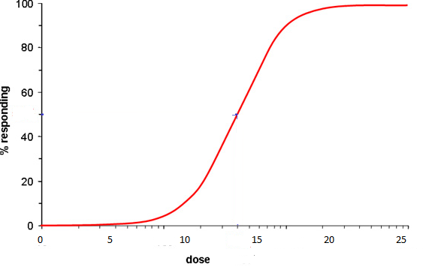

1. If another line was added to the graph that was to the right of the current line with the exact same shape, would the LD50 be more or less than the original line?
2. What are the pathways of exposure?
3. What is the difference between acute and chronic exposure?
4. What are some of the effects of mercury and lead on a human body?
5. Define the following words:

Dose –

Response –

Toxicology –

Toxicity –

Toxin –

Exposure –

LD50 –

Acute –

Chronic –

1. How does Erin Brockovich relate to toxicology? What is the toxin, what does the toxin cause, how were people exposed? Why should we be cautious about exposure to chemicals?
2. Make sure you can interpret an LD50 graph. You will be asked to graph data and interpret the graph to determine the LD50 of a substance.
3. From the powerpoint that everyone made about specific toxins, make sure you know 1 or 2 well. Bring your note sheet from that powerpoint as well – you will be allowed to use it for part of the test.