# Unit IIB Review Questions

**Multiple Choice**

*Identify the choice that best completes the statement or answers the question.*

____ 1. Sarah's accountant tells her that she made a profit of $43,002 running a pottery studio in Orlando. Sarah's husband—an economist—claims Sarah lost $43,002 running her pottery studio. This means her husband is claiming that she incurred ________ in ________ costs.

1. $86,004; implicit
2. $43,002; implicit
3. $43,002; explicit
4. $86,004; explicit
5. $0; explicit

____ 2.

| **Quantity**  **of Gadgets**  **Produced** | **Total Cost** |
| --- | --- |
| 0 | $100 |
| 1 | $105 |
| 2 | $110 |
| 3 | $115 |
| 4 | $120 |
| 5 | $125 |
| **Table: The Cost of Producing Gadgets** | |

You own a small manufacturing company that produces gadgets. The table shows the quantity of gadgets that you could produce, and the total cost you incur at each level of production. According to this table, marginal cost is:

1. increasing at a constant rate.
2. increasing at an increasing rate.
3. increasing at a decreasing rate.
4. constant and equal to $5.
5. decreasing.

____ 3. At 76 units of labor, a firm finds that average product of labor equals 39.6 and marginal product of labor equals 42.9. We can conclude that the average product curve at 76 units of labor is:

1. upward-sloping.
2. downward-sloping.
3. vertical.
4. horizontal.
5. maximized.

| **Number**  **of Workers**  **Per Period** | **Thousands**  **of Bagels**  **Per Period** |
| --- | --- |
| 0 | 0 |
| 1 | 5 |
| 2 | 15 |
| 3 | 30 |
| 4 | 42 |
| 5 | 51 |
| 6 | 57 |
| 7 | 60 |
| 8 | 50 |
| 9 | 57 |
| **Table 54-5: Production of Bagels** | |

____ 4. (Table 54-5: Production of Bagels) Diminishing marginal returns begin with the addition of the ________ worker.

1. third
2. fourth
3. fifth
4. sixth
5. eighth

| **Quantity**  **of Output** | **Variable Cost**  **VC** | **Total Cost**  **TC** |
| --- | --- | --- |
| 0 | 0 | 50 |
| 1 | 50 | 100 |
| 2 | 70 | 120 |
| 3 | 100 | 150 |
| 4 | 140 | 190 |
| 5 |  | 240 |
| 6 | 250 | 300 |
| 7 | 320 | 370 |
| **Table 55-1: Cost Data** | | |

____ 5. (Table 55-1: Cost Data) The table shows some cost data for a firm currently operating in the short run. What is the value of the total variable cost for this firm when the firm is producing five units of output?

1. $50
2. $240
3. $60
4. $190
5. It is impossible to determine without more information.

____ 6. Suppose Cyd knows the average cost of producing 9 scones is $5, while the average cost of producing 10 scones is $5.20. What is the marginal cost of the 10th unit?

1. $7
2. $5.20
3. $0.20
4. $5
5. $10.20

____ 7. In the short run, as output gets larger and larger:

1. total fixed cost gets smaller.
2. the average variable cost curve gets closer and closer to the average total cost curve.
3. marginal cost gets smaller.
4. average total cost decreases after the point of diminishing returns.
5. the average product curve reaches a minimum point and begins to rise.

____ 8. If marginal cost is equal to average total cost, then:

1. average total cost is increasing.
2. average total cost is at its maximum.
3. average total cost is at its minimum.
4. marginal cost is increasing.
5. average variable cost is decreasing.

____ 9. The long-run average total cost of producing 100 units of output is $4, while the long-run average cost of producing 110 units of output is $4. These numbers suggest that the firm producing this output is experiencing:

1. economies of scale.
2. diseconomies of scale.
3. constant returns to scale.
4. diminishing marginal returns.
5. increasing returns to scale.

____ 10. A monopolistically competitive industry is made up of:

1. a few firms, each producing a very differentiated good.
2. one firm that produces a very standardized good.
3. market participants who are all price-takers.
4. many firms producing a differentiated product.
5. many firms producing an identical product.

____ 11. The demand curve for a perfectly competitive firm is:

1. perfectly inelastic.
2. perfectly elastic.
3. downward-sloping.
4. relatively, but not perfectly elastic.
5. non-existent.

____ 12. Suppose a perfectly competitive firm can increase its profits by increasing its output. Then it must be the case that the firm's:

1. marginal revenue exceeds its marginal cost.
2. price exceeds its average variable cost, but is less than average total cost.
3. marginal cost exceeds its marginal revenue.
4. price exceeds its marginal revenue.
5. price is less than marginal revenue.

____ 13. Zoe's Bakery operates in a perfectly competitive industry. Suppose that when the market price is $5, the profit-maximizing output level of pastries is 150 units, with average total cost of $4, and average variable cost of $3. From this we know Zoe's marginal cost is ________, and her short-run profits are ________.

1. $2; $150
2. $5; $300
3. $1; $150
4. $1; $300
5. $5; $150

____ 14. Zoe's Bakery operates in a perfectly competitive industry. The variable costs at Zoe's Bakery increase, so all the cost curves (with the exception of fixed cost) shift upward. The demand for Zoe's pastries does not change, nor does the firm shut down. Hence, Zoe's Bakery will ________ its price and ________ its level of production.

1. raise; increase
2. decrease; increase
3. raise; decrease
4. not change; decrease
5. not change; not change

____ 15. If price is currently between average variable cost and average total cost, then in the short run a perfectly competitive firm should:

1. shut down.
2. continue to produce to minimize losses.
3. raise price.
4. increase production to increase profit.
5. reduce production to increase profit.

**Figure 59-3 : Profit Maximizing**

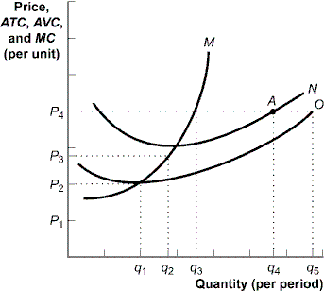

____ 16. (Figure 59-3: Profit Maximizing) The figure shows cost curves for a firm operating in a perfectly competitive market. If the market price is *P*3, the firm will produce quantity ________ and ________ in the short run.

1. q2; make a profit
2. q1; break even
3. q2; incur a loss
4. q4; incur a loss
5. q1; incur a loss

**Figure 59-4: A Perfectly Competitive Firm in the Short Run**

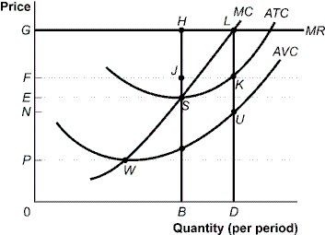

____ 17. (Figure 59-4: A Perfectly Competitive Firm in the Short Run) The firm's total revenue from the sale of its most profitable level of output is:

1. 0GLD.
2. 0GHB.
3. BH.
4. DL.
5. NFKU.

____ 18. In the short run, if *P* < *AVC,* a perfectly competitive firm:

1. produces output and earns an economic profit.
2. produces output and incurs an economic loss.
3. does not produce output and earns an economic profit.
4. does not produce output and incurs an economic loss.
5. produces output and earns zero economic profit.

____ 19. Lilly is the price-taking owner of an apple orchard. Currently the price of apples is high enough that Lilly is earning positive economic profits. In the long run, Lilly should expect:

1. lower apple prices due to entry of new firms.
2. higher apple prices due to exit of existing firms.
3. lower apple prices due to exit of existing firms.
4. higher apple prices due to entry of new firms.
5. no change in apple prices.

____ 20. In the long run, each firm in a perfectly competitive industry will:

1. produce at the point where average variable cost is minimized.
2. produce where MR is greater than MC.
3. differentiate its goods.
4. increase its price.
5. earn a normal profit.

| **Quantity**  **(megawatts)** | **Price per**  **Megawatt** | **Total Cost** |
| --- | --- | --- |
| 1 | $550 | $1,000 |
| 2 | 500 | 1,075 |
| 3 | 450 | 1,200 |
| 4 | 400 | 1,375 |
| 5 | 350 | 1,600 |
| 6 | 300 | 1,875 |
| 7 | 250 | 2,200 |
| 8 | 200 | 2,575 |
| **Table 61-1: Demand and Total Cost** | | |

____ 21. (Table 61-1: Demand and Total Cost) Lenoia runs a natural monopoly firm producing electricity for a small mountain village. The table shows Lenoia's demand and total cost of producing electricity. To maximize profits, Lenoia should charge a price of:

1. $350.
2. $400.
3. $450.
4. $500.
5. $300.

____ 22. Which of the following statements about monopoly equilibrium and perfectly competitive equilibrium is *incorrect*?

1. Price is greater than marginal cost in monopoly, and price equals marginal cost in perfect competition.
2. When a monopoly exists, the consumer surplus is less than if the market were perfectly competitive.
3. Monopoly output will be less than the output of a comparable perfectly competitive industry.
4. In the long run, economic profits are driven to zero in both a monopoly and a perfect competitive market.
5. In the long run, entry of new firms is prevented in a monopoly.

____ 23.

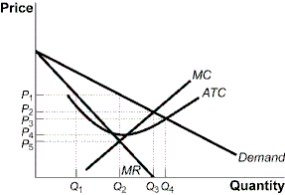

The graph shows a monopoly firm that sells gadgets. If the firm is regulated such that the firm earns zero economic profit, the firm will sell ________ units at a price of ________ per unit.

1. Q1; P1
2. Q2; P1
3. Q4; P3
4. Q3; P2
5. Q3; P3

____ 24. A monopolist or an imperfectly competitive firm practices price discrimination primarily to:

1. increase profits.
2. expand plant size.
3. lower total costs.
4. reduce marginal costs.
5. increase consumer surplus.

**Figure 65-1: Payoff Matrix for Jake and Zoe**

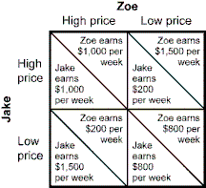

____ 25. (Figure 65-1: Payoff Matrix for Jake and Zoe) Jake and Zoe are the only producers of slushies in Vacatown. Each week, each firm decides whether to price high or price low for the following week. The figure shows the profit per week earned by the two firms. What is the Nash equilibrium for Jake and Zoe?

1. Jake prices high; Zoe prices high
2. Jake prices high; Zoe prices low
3. Jake prices low; Zoe prices high
4. Jake prices low; Zoe prices low
5. This game does not have a Nash equilibrium.

**Figure 67-8: Profits in Monopolistic Competition**

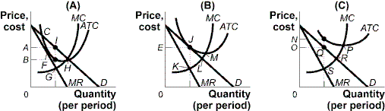

____ 26. (Figure 67-8: Profits in Monopolistic Competition) Long-run equilibrium is illustrated at the profit-maximizing price ________ in panel ________.

1. A; A
2. E; B
3. B; A
4. N; C
5. L; B

**Figure 67-9: The Restaurant Market**

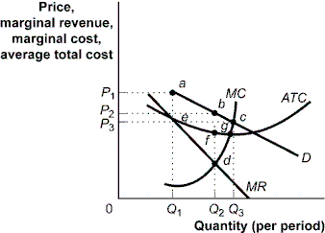

____ 27. (Figure 67-9: The Restaurant Market) The figure shows curves facing a typical restaurant in a community. Assume that many firms, differentiated products, and easy entry and easy exit characterize the market. In long-run equilibrium, the economic profit earned by the typical restaurant in the community will be:

1. negative, as price will be less than average total cost.
2. zero, as price will equal average total cost.
3. positive, as price will exceed average total cost.
4. negative, as price will be equal to average total cost.
5. zero, as price will exceed average total cost.

**Unit IIB Review Questions**

**Answer Section**

**MULTIPLE CHOICE**

1. ANS: A

2. ANS: D

3. ANS: A

4. ANS: B

5. ANS: D

6. ANS: A

7. ANS: B

8. ANS: C

9. ANS: C

10. ANS: D

11. ANS: B

12. ANS: A

13. ANS: E

14. ANS: D

15. ANS: B

16. ANS: C

17. ANS: A

18. ANS: D

19. ANS: A

20. ANS: E

21. ANS: B

22. ANS: D

23. ANS: C

24. ANS: A

25. ANS: D

26. ANS: B

27. ANS: B